The Town of Gates Highway Department is responsible for ensuring the safety of our local roadways at an effective cost for our residents. One way of accomplishing this is through preventive maintenance of the asphalt pavement. This summer, the Department will be using a chip seal application on over 7 miles of our local roads. Chip sealing is a common maintenance practice that rejuvenates and rehabilitates the asphalt wear course. Chip sealing helps maintain a good driving surface and extends the service life of the underlying pavement.

Why is Preventative Maintenance Important?

As shown in the following graph from the American Society of Civil Engineers (ASCE), an asphalt pavement’s condition deteriorates over time, and ultimately requires some maintenance to stay above minimum acceptable levels.

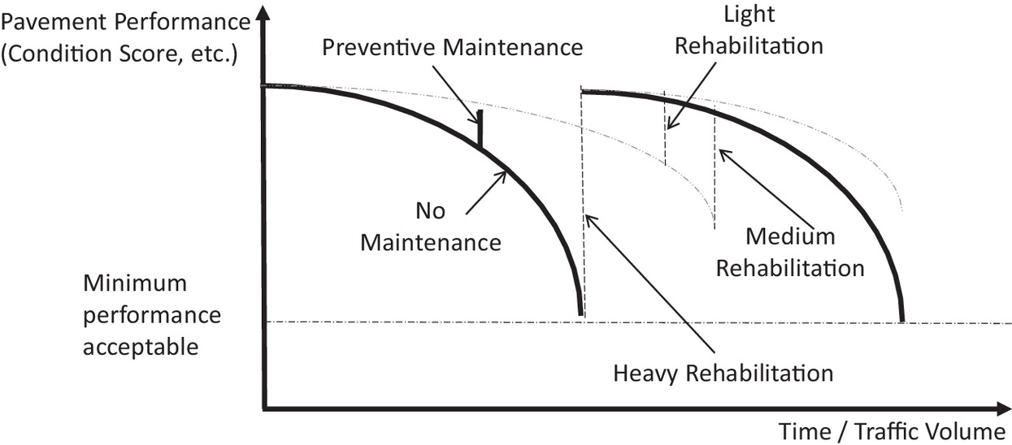

Timely preventative maintenance raises and extends the curve, keeping the roadway in good condition for longer. Heavy rehabilitation practices such as milling and paving can cost four to five times more per mile than the chip seal preventative maintenance practice.

Without preventative maintenance, we would expect a local road to last 20 to 25 years. A chip seal application would extend the life of the roadway approximately 5 to 7 years. Regular chip sealing results in lower costs over the long term.

What is Chip Sealing?

Chip sealing is a maintenance practice where a layer of small stone aggregate and hot liquid asphalt is placed atop an asphalt roadway. It is essentially the same materials as hot mix asphalt overlay, just a different construction method.

How is the chip seal applied?

For the Town of Gates, chip sealing is done in three (3) phases.

- Phase 1 - Hot Patching. The Town’s Highway crews will repair and replace any poor or weak parts of the pavement, such as potholes. The crews will also make any repairs to the underlying drainage system, or other surface changes to improve drainage of the roadway.
- Phase 2 - Chip Sealing. First, the roadway is swept of any dirt or debris to ensure a good tack and a better product. A liquid asphalt distributor truck then sprays a thin layer of hot liquid asphalt onto the roadway, which also seals any cracks in the surface. The sprayer truck is then quickly followed by a spreader that lays down a layer of small stone aggregate, and a roller then sets the stone into the asphalt liquid, providing a tighter chip seal. This process doesn’t take long, and the public can drive (slowly) on the chip sealed road right away. A few hours after chip sealing, the roadway is swept of any loose stones, and again a few days later.
- Phase 3 - Fog Sealing. A week or so after chip sealing, a second layer of hot liquid asphalt, known as a fog seal, is applied. This further helps protect the chip seal product and the roadway, significantly reduces tire noise, eliminates dust, and leaves a black, hard-wearing surface.
When can I drive on the chip sealed surface?

You can drive on the chip sealed surface right away. However, we ask that you please drive at 20 MPH or less, as excessive speeds can break the fresh surface and toss chips into the air at people, cars, onto lawns, or at your own vehicle. Also, quick acceleration and braking can marr the chips, causing the surface to washboard and resulting in a bumpy ride. Washboarding cannot be fixed.

Normal speeds can resume a day or two after chip sealing, and a couple hours after the roadway has been fog sealed.

Where is chip seal being used?

In 2020, the Town is planning on chip sealing the streets shown on the map below. Those residents have been notified by letter with additional details.

Are there local examples of chip sealed roads?

Last summer, Monroe County chip sealed Lyell Road between Elmgrove Road and Manitou Road. The only difference between this and what the Town has planned is the fog seal application. This section of Lyell Road has a heavier traffic volume than most of our local roads.

Most of the towns in Monroe County use chip sealing as a major part of their road program.

Is there more information?

Yes! Check out this video and website on the chip sealing process and its benefits from the Kent County Road Commission in Michigan.
How Chip Seal Helps Preserve Our Roads
Why Are You Putting Tar and Gravel on Paved Roads?

Or this video from Johnson County in Kansas:
What is chip sealing?

Or this video from Ada County in Idaho:
Chip Sealing: The Basics

